Section 1: Exploring Different Media
(Choose ONE or more types of media)
Examples of Media (you may choose from these or suggest your own):
- Films or TV series
- Written novels (fiction, fantasy, sci-fi, mythology, historical)
- Graphic novels or comics
- Illustration or concept art
- Animation
- Sculpture or architecture
Task:
Choose a media source that interests you.
Media Type: Film
Title / Name of Source: V/H/S/94 (2021)
Author / Artist / Studio / Publisher: Shudder
Description:
- What is this media about?
- What genre does it belong to?
(Fantasy, Sci-Fi, Mythological, Horror, Adventure, Historical, etc.)
A police S.W.A.T. team investigate a mysterious VHS tape and discover a cult that has recordings which uncover a conspiracy.
Found footage horror anthology film
Visual & Narrative Analysis:
- If written: how does it describe settings, characters, or atmosphere?
- If visual: what art style, colour palette, or composition is used?
- How does this media communicate mood, theme, or story?
From watching the trailer, I have gathered that this film is shot in the low quality that you would expect from VHS tapes, making the film seems almost home-made, like the ‘creepy videos’ you will find on YouTube. This trailer also uses brief moments of quiet and normality to raise suspense to the viewer.
Games Design Connection:
- How could this media inspire a game?
- Consider: World/Environment design, Character concepts, Narrative, Gameplay
There are a few ways that media like this can inspire game development. For example, you could be inspired by some of the creatures in the film, helping you come up with ideas for creature/monster design. Furthermore, you may also be inspired by it’s rustic, almost home-made, style. This style could be used to create retro-styled horror games or games that are from the perspective of a recording. Furthermore, the game could also more simply be focussed around exploring tapes and discovering a mystery.
Insert images here
(book covers, panels, illustrations, screenshots, fan art – credited)
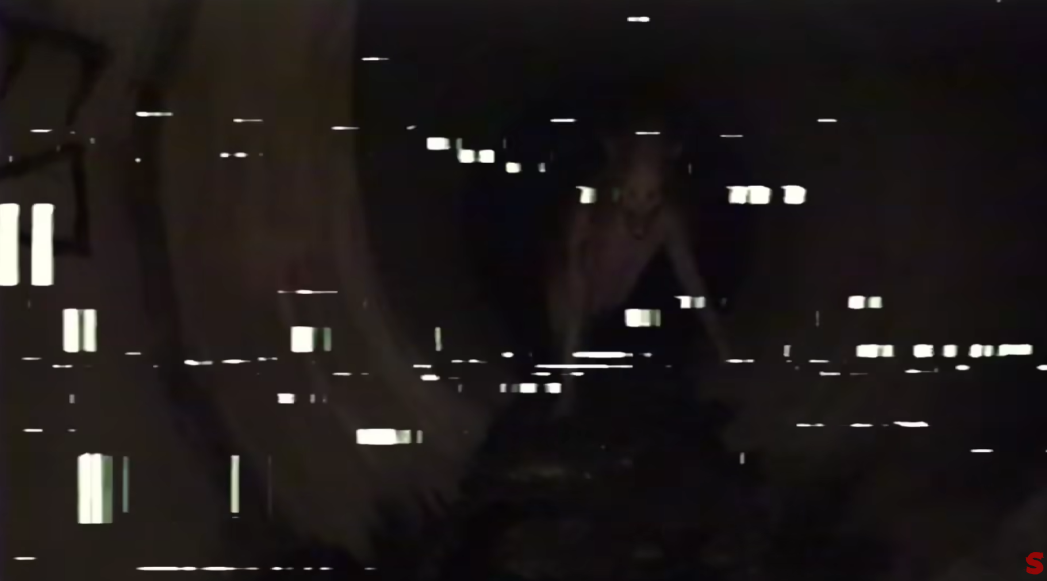
V/H/S/94 Trailer: Screenshot
List your sources
(websites, books, videos, etc.)
Wikipedia Contributors (2026). V/H/S/94. Wikipedia.
Shudder (2021). V/H/S/94 - Official Trailer [HD] | A Shudder Original. YouTube. Available at: https://www.youtube.com/watch?v=opnSln8Ue2U [Accessed 23 Oct. 2021].

Section 2: Old Stories & Ancient Myths
(Choose ONE story, legend, or myth)
Examples:
- Greek, Norse, Egyptian, Celtic, Aztec myths
- Epic poems or legends (The Odyssey, Beowulf)
- Folklore or ancient storytelling traditions
Story / Myth Name: Prometheus and the Theft of Fire
Culture / Origin: Greek Mythology
Summary:
- What happens in this story?
- Who are the main characters?
Prometheus stole fire from the gods and gave it to mankind. Zeus discovered this and became very angry, punishing and torturing Prometheus for eternity. Every day, Zeus would send an eagle to eat Prometheus’s liver whilst he was chained to a rock at the top of a mountain.

Themes & Ideas:
- What themes does it explore?
(Power, fate, revenge, heroism, sacrifice, nature, the afterlife, etc.)
Sacrifice, punishment, power of the gods.

Visual & Narrative Potential:
- What locations, creatures, or objects stand out?
- How could this story be reimagined in a modern game?
The mountain, Caucasus, which Prometheus was chained on.
Hephaestus' workshop, where Prometheus stole the fire.
The eagle that came and ate Prometheus’s liver every day.
Prometheus, the thief of fire.
This story could be reimagined in a modern game, for example, in an educational game about Greek mythology and its stories. Furthermore, it could inspire a game about punishment and criminals.

Games Design Connection:
- Would this work better as: An action game? RPG? Narrative-driven experience?
- Why?
I believe that this story would best work in a narrative driven game, where this story is told in a playable experience with cutscenes and different choices to lead to a different ending. I believe this as this story was created to warn people from stealing and defying the gods, a game about this story would likely also be framed as an educational story.

Insert reference images (art, statues, paintings, maps)
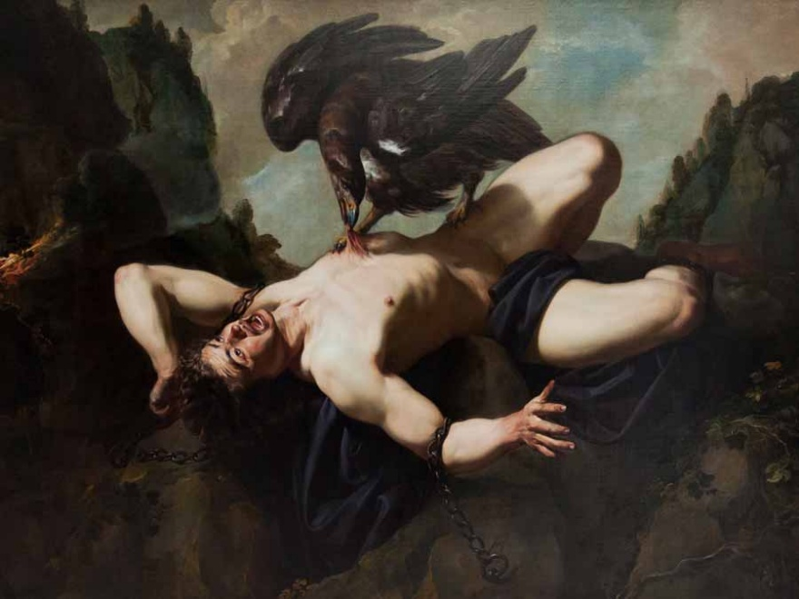
List your sources
Greek Travel Tellers (2019). 30 of the Most Famous Tales from Greek Mythology. [online] greektraveltellers.com. Available at: https://greektraveltellers.com/blog/30-of-the-most-famous-tales-from-greek-mythology.
‌

Section 3: Ancient Gods & Heroes
(Choose ONE God, goddess, or hero that is not Thor or Loki. Be original)
Examples:
- Zeus, Athena, Odin, Anubis, Quetzalcoatl
- Hercules, Achilles, Gilgamesh, Mulan
Name: Hades
Culture / Mythology: Greek Mythology
Description:
- What are they the god/hero of?
- What powers, traits, or symbols are they associated with?
He is God of the Underworld, Ruler of the Dead.
Whilst modern media associates him with death, he is actually not the god responsible for death in mythology, he is simply the one who keeps the souls of the dead trapped in his kingdom.
Iconography & Design:
- How are they usually depicted visually?
- Colours, clothing, weapons, animals, symbols?
Whilst in modern media Hades is portrayed as horrifying and unnatural in appearance, to the Ancient Greeks he was very human in appearance. We see this in their sculptures of Hades.

Games Design Connection:
- How could this character be adapted into a game?
- Would they be: A playable character? A boss? A guide or NPC?
If this God was to be put realistically into a game, he would likely be an NPC or guide in the underworld area. Not being a violent monster, but instead a guide for the dead.

Insert images or sketches
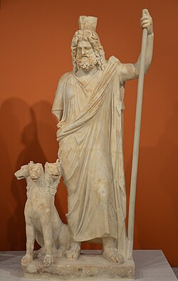
List your sources
Wikipedia Contributors (2018). Hades. [online] Wikipedia. Available at: https://en.wikipedia.org/wiki/Hades.
‌

Section 4: Animals & Habitats
(Choose ONE animal or habitat)
Examples:
- Deep sea creatures
- Rainforest animals
- Desert wildlife
- Arctic species
- Extinct animals
Animal / Habitat:
Facts & Information:
- Where does it live?
- What makes it interesting or unusual?
- Any unique behaviours or adaptations?
Answer here

Visual Inspiration:
- Shapes, patterns, movement, textures?
- How could this influence creature or environment design?
Answer here

Games Design Connection:
- Could this inspire: A creature or enemy? A playable character? A game environment or biome?
Answer here

Insert images or diagrams

List your sources

Section 5: Video Games as Research Sources
(Choose ONE game to explore in depth)
This section focuses on analysing games as designed experiences, not just playing them.
Game Title:
Developer / Studio:
Release Year / Platform:
Exploration Tasks:
- What genre is this game?
- What makes this game interesting or different from others?
- How does the game use: Environment design? Characters or creatures? Storytelling or lore? Gameplay mechanics?
Answer here

Design Focus:
- What design choices stand out?
- How does the game guide or challenge the player?
Answer here

Games Design Inspiration:
- What ideas could you take from this game for your own project?
- Would you adapt: Mechanics? Worldbuilding? Visual style? Player experience?
Answer here

Include screenshots or concept art (credited)
List your sources

Section 6: Hobbies & Personal Interests as Creative Research
(Choose or find ONE hobby or personal interest)
Examples of Hobbies & Interests (Choose or Suggest Your Own)
You may explore traditional, physical, creative, cultural, or niche interests, such as:
- Tabletop role-playing games (D&D, Call of Cthulhu, Pathfinder)
- Skateboarding, BMX, freerunning
- Urban exploration (abandoned buildings, ruins)
- Wildlife watching or nature photography
- Mythology collecting or folklore research
- Calligraphy, tattoo design, or symbolic art
- Costume making / cosplay
- Cultural crafts (weaving, pottery, mask making)
- Astronomy or stargazing
Research Tasks
Hobby / Interest Chosen:
Why are you interested in this?
(What drew you to it?)
Exploration:
- What skills, tools, or knowledge does this hobby involve?
- Is there history, culture, or tradition behind it?
- What makes this hobby interesting or unique?
Answer here

Visual & Experiential Elements:
- What visuals are connected to this hobby? Equipment, clothing, environments, symbols?
- What does it feel like to take part in it? Speed, tension, calm, danger, focus?
Answer here

Games Design Inspiration:
- How could this hobby influence a game? Mechanics (movement, combat, crafting, puzzles)? World or environment design? Characters, factions, or abilities? Player experience or emotion?
Answer here

Include photos, diagrams, or sketches
List your sources

